Lab 4 – Log Shipping Configuration for SQL Server
Pre-requisites - The primary database must use the full or bulk-logged recovery model; switching the database to simple recovery will cause log shipping to stop functioning.
Before you configure log shipping, you must create a share to make the transaction log backups available to the secondary server. This is a share of the directory where the transaction log backups will be generated. For example, if you back up your transaction logs to the directory C:\data\tlogs\, you could create the \\<primaryserver>\tlogs share of that directory.

Permissions
The log shipping stored procedures require membership in the sysadmin fixed server role.

Create new Primary & Secondary database & a table.
-- Create database --

create database "amdocssqltraining"
go

-Create table ---
Create table Product (
ProductId nchar(10) NOT NULL,
ProductName nvarchar(50) NOT NULL,
ProductCost nvarchar(50) NoT NULL,
ProductDescription nvarchar(MAX) NULL)

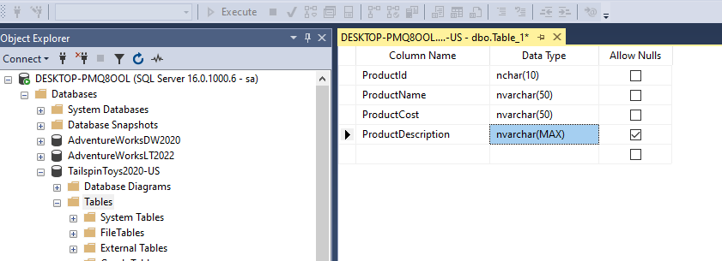

Configure log shipping
You can configure log shipping by using either Management Studio or Transact-SQL. The tabs in this section describe how to configure log shipping by using each method.
SQL Server Management Studio
Transact-SQL
To configure log shopping by using Management Studio, follow these steps:
- Right-click the database you want to use as your primary database in the log shipping configuration, and then select Properties.
- Under Select a page, select Transaction Log Shipping.
- Select the Enable this as a primary database in a log shipping configuration check box.
- Under Transaction log backups, select Backup Settings.
- In the Network path to the backup folder box, type the network path to the share you created for the transaction log backup folder.
- If the backup folder is located on the primary server, type a local path in the backup folder box. (If the backup folder isn't on the primary server, you can leave this box empty.)
Important
If the SQL Server service account on your primary server runs under the local system account, you must create your backup folder on the primary server and specify a local path to that folder.
- Configure the Delete files older than and Alert if no backup occurs within parameters.
- Note the backup schedule listed in the Schedule box under Backup job. If you want to customize the schedule for your installation, then select Schedule and adjust the SQL Server Agent schedule as needed.
- SQL Server supports backup compression. When creating a log shipping configuration, you can control the backup compression behavior of log backups by choosing one of the following options: Use the default server setting, Compress backup, or Do not compress backup. For more information, see Log Shipping Transaction Log Backup Settings.
- Select OK.
- Under Secondary server instances and databases, select Add.
- Select Connect and connect to the instance of SQL Server that you want to use as your secondary server.
- In the Secondary Database box, choose a database from the list or type the name of the database you want to create.
- On the Initialize Secondary database tab, choose the option that you want to use to initialize the secondary database.
Note
If you choose to have Management Studio initialize the secondary database from a database backup, the data and log files of the secondary database are placed in the same location as the data and log files of the master database. This location is likely to be different than the location of the data and log files of the primary database.
- On the Copy Files tab, in the Destination folder for copied files box, type the path of the folder into which the transaction logs backups should be copied. This folder is often located on the secondary server.
- Note the copy schedule listed in the Schedule box under Copy job. If you want to customize the schedule for your installation, select Schedule and then adjust the SQL Server Agent schedule as needed. This schedule should approximate the backup schedule.
- On the Restore tab, under Database state when restoring backups, choose the No recovery mode or Standby mode option.
Important
Standby mode is only an option when the version of the primary and secondary server are the same. When the major version of the secondary server is higher than the primary, only No recovery mode is allowed
- If you chose the Standby mode option, choose if you want to disconnect users from the secondary database while the restore operation is underway.
- If you want to delay the restore process on the secondary server, choose a delay time under Delay restoring backups at least.
- Choose an alert threshold under Alert if no restore occurs within.
- Note the restore schedule listed in the Schedule box under Restore job. If you want to customize the schedule for your installation, select Schedule and then adjust the SQL Server Agent schedule as needed. This schedule should approximate the backup schedule.
- Select OK.
- Under Monitor server instance, select the Use a monitor server instance check box, and then select Settings.
Important
To monitor this log shipping configuration, you must add the monitor server now. To add the monitor server later, you would need to remove this log shipping configuration and then replace it with a new configuration that includes a monitor server.
- Select Connect and connect to the instance of SQL Server that you want to use as your monitor server.
- Under Monitor connections, choose the connection method to be used by the backup, copy, and restore jobs to connect to the monitor server.
- Under History retention, choose the length of time you want to retain a record of your log shipping history.
- Select OK.
- On the Database Properties dialog box, select OK to begin the configuration process.

